API Assignment  
By github.com/schmwong

1. Consuming a Bank API (30%)   
   ○  Reviewing the API documentation, and test the API from Postman

1.1: API Documentation: [OCBC 360 Interest Rate Calculator](https://api.ocbc.com/store/OCBC/apis/documentation?title=360%20Interest%20Rate%20Calculator&name=OCBC360_Interest&type=Informational)

1.2: Screenshot of testing the API in Postman.   
Refer to file “1. BankAPI Postman.png”

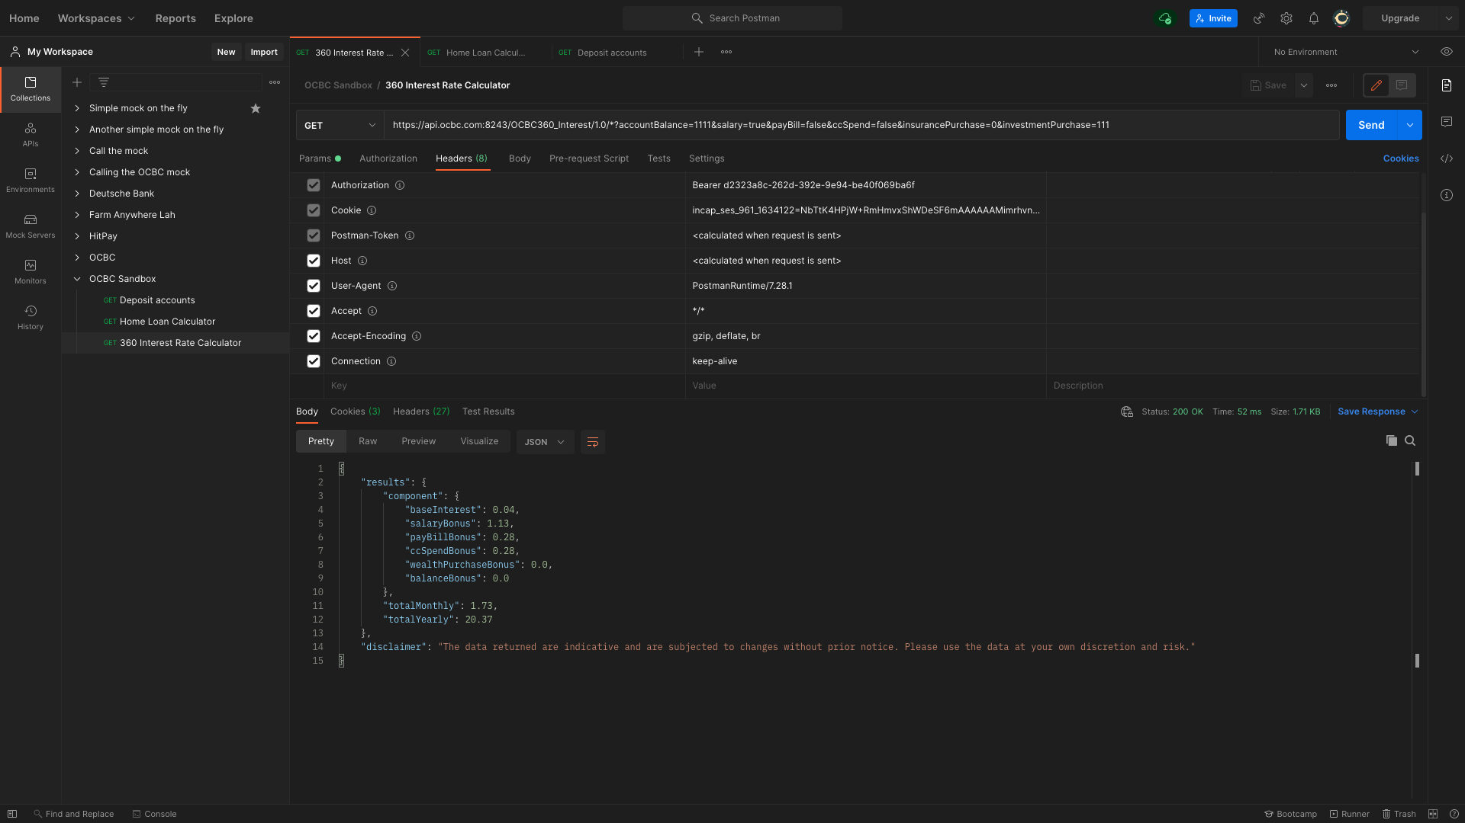

○  BONUS: Calling the API from JavaScript

1.3: Screenshot of calling the API in JavaScript  
Refer to files “1. BankAPI JavaScript Call.png”, “callOCBC.js”

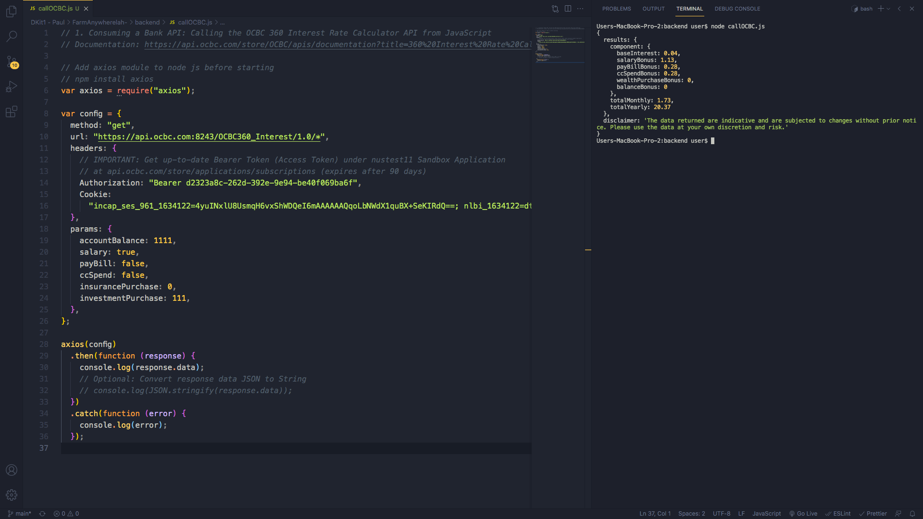

1. Executing a Payments API (40%)

○  Reviewing the API documentation, and test the API,

2.1: API Documentation: [HitPay Create Payment Request API](https://hit-pay.com/docs.html?shell#payment-requests)

2.2: Screenshot of testing the API in Postman.   
Refer to file “1. PaymentsAPI Postman.png”

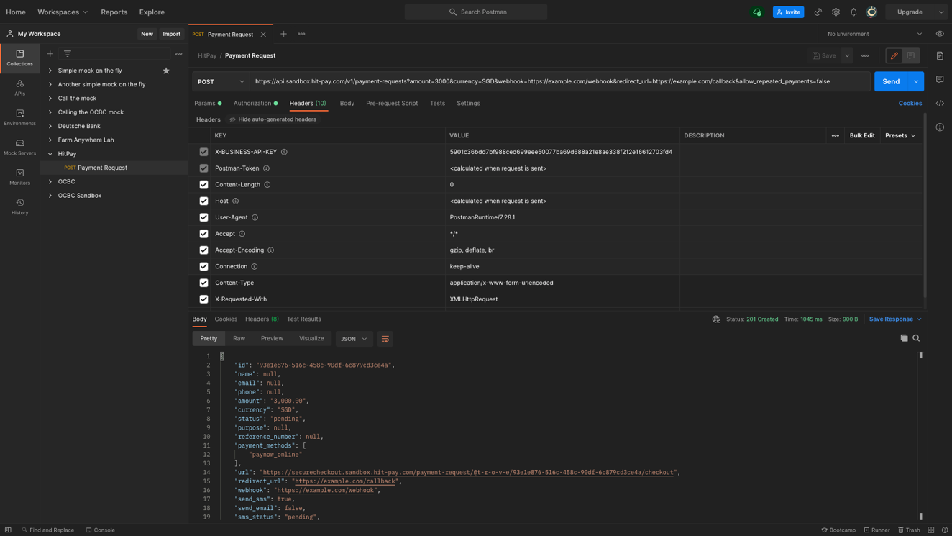

○  BONUS: Calling the API from JavaScript

2.3: Screenshot of calling the API in JavaScript  
Refer to files “1. PaymentsAPI JavaScript Call.png”, “callHitPay.js”

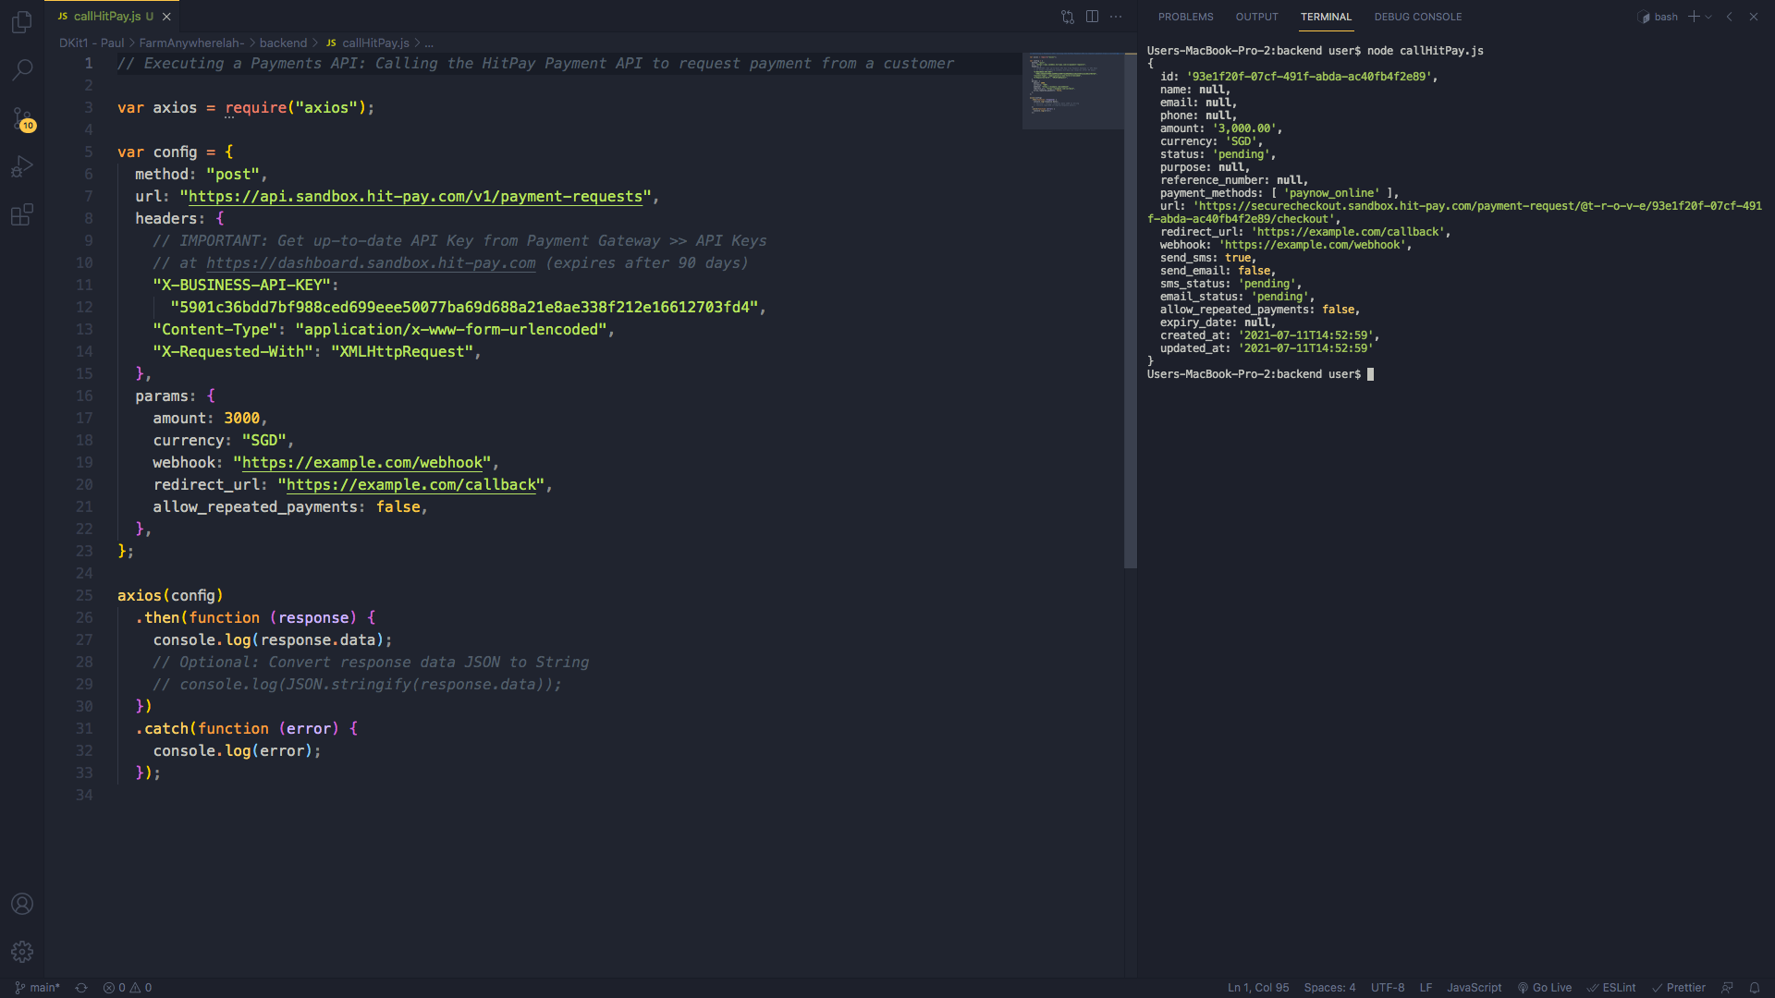

1. Designing an API (30%)

○ Suggest an API that could be built to expose a service. This could be a new or existing service, data, or combination of several services.

Living and working in densely populated urban areas such as Singapore equates having to bear with to commuter and vehicular traffic congestion at certain times of the day. Oftentimes, people meeting up after work or on weekends face difficulties when they arrive only to find the place packed, or the one party might be caught up in vehicular traffic, finally find a parking space, and then struggle to get through the human traffic — with COVID pandemic regulations limiting entry and exit points and whatnot — only to arrive much later than the other party.

If the data generated by the traffic monitoring systems used by Singapore’s Land Transport Authority (LTA) and footfall counting solutions used indoors could be somehow aggregated, one would be able to have a good overview of current and forecasted traffic density along the entire route — roadway, public transport service or carpark, building entrances, shops, lift landings, linkbridges and thoroughfares — and be able to chart the quickest possible route to one’s destination.

**References**

Road and Carpark Traffic Monitoring:

LTA: APIs

<https://datamall.lta.gov.sg/content/datamall/en/dynamic-data.html>

LTA: Intelligent Transport Systems

<https://www.lta.gov.sg/content/ltagov/en/getting_around/driving_in_singapore/intelligent_transport_systems.html>

LTA, A*STAR: CoopeRative and UnIfied Smart Traffic Control System (CRUISE)

<https://www.youtube.com/watch?v=8uVpZcwHk_g>

Footfall Traffic Monitoring:

Trakomatic

<https://www.trakomatic.com/people-counting-system>

Skywave

<https://skywave.com.sg/#get-counted-with-skywave>